ASSIGNMENT 4

CASE STUDY:

Student is enrolled in a course. Each student is identified by his roll number. Other attributes of student are name, Dob, and semester. Each course has a unique course number. Other attributes of course are course name and number of students. Students are taught by faculty and faculties are working in course. Each faculty have a unique faculty number. Other attributes are name, course and salary. Draw an ERD and create the database for this scenario. Following constraint must be considered:

1. Student’s roll number should be unique and can not be left blank.

2. Student name cannot be left blank.

3. Course number should be unique and cannot be left blank.

4. Any column of course table cannot be left blank.

5. Course can only be ‘BCA’,’MCA’,’M.SC IT’

6. Faculty number should be unique and cannot be left blank.

7. Salary of faculty can not be a negative number.

8. You can assume other attributes of your choice.

1. Create Student table

QUERY:

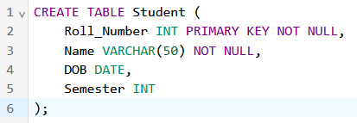

Create Course Table

QUERY:

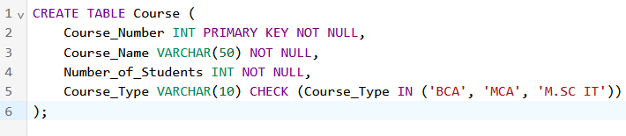

Create Faculty Table

QUERY:

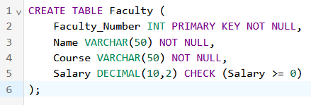

Create Enroll table

QUERY:

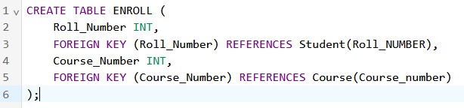

Create Works Table

QUERY:

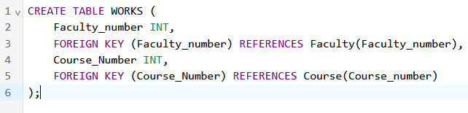

Create Teach table

QUERY:

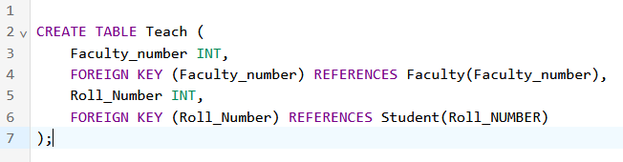

Insert into Student table:

QUERY:

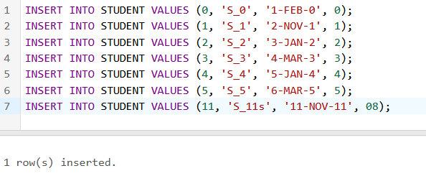

Insert into Course table:

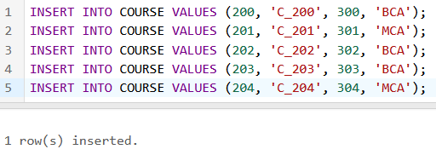

Insert into Faculty table:

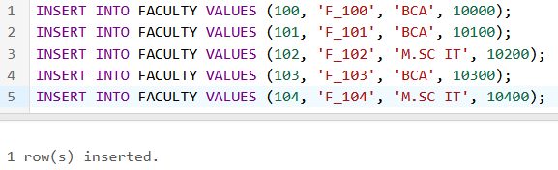

INSERT into Enroll, Teach, Works tables:

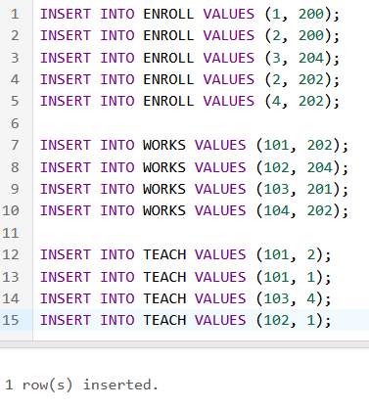

1. Retrieve the information of those students who are taught by faculty 101.

QUERY:

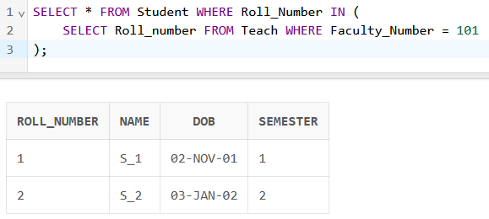

2. Retrieve record of faculty whose faculty number = 104.

QUERY:

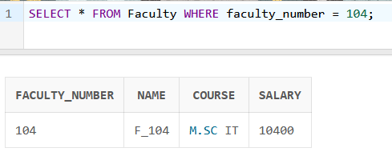

3. Display the information of the students whose name ends with ‘s’.

QUERY:

